Full Object-Oriented Programming (OOP) Concept in C++
1. Introduction to OOP
Object-Oriented Programming (OOP) is a programming paradigm where software is designed using objects.
An object represents a real-world entity that has:
- Attributes → Data or properties (variables).
- Behaviors → Functions or actions (methods).
Why OOP?
- Organizes code better than procedural programming.
- Improves modularity, reusability, and maintainability.
- Suitable for complex and large-scale projects.

2. Key Principles of OOP
2.1 Encapsulation
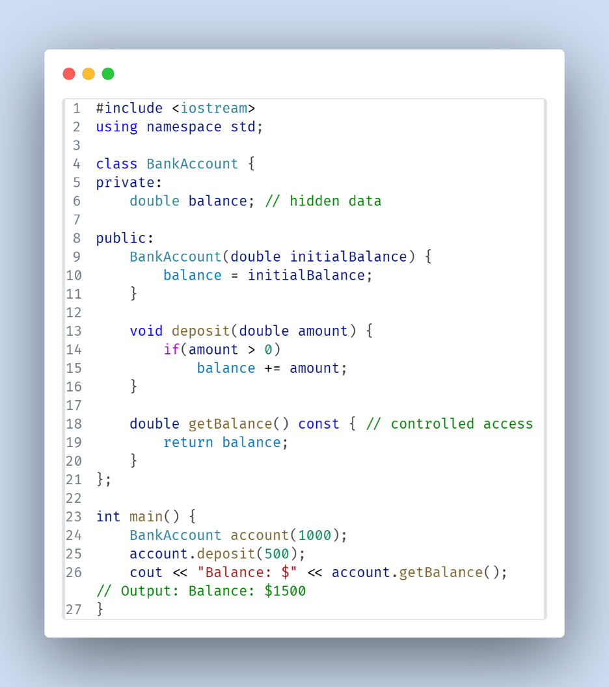
Definition: Bundling data and the functions that operate on that data into a single unit (class) and restricting direct access to the internal representation.
How to Achieve:
- Use access specifiers:
  - private: Accessible only within the class.
  - protected: Accessible within the class and derived classes.
  - public: Accessible from anywhere.
Advantages:
- Protects data from unintended changes.
- Allows controlled access via getter/setter functions.
2.2 Abstraction
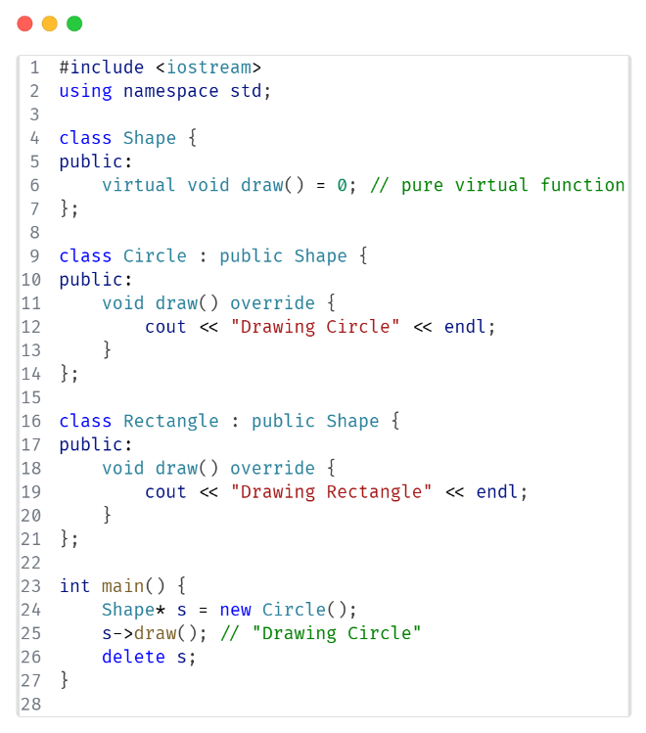
Definition: Hiding internal implementation details and showing only the necessary information to the outside world.
How to Achieve:
- Use abstract classes (classes with pure virtual functions).
- Use interfaces (in C++, achieved with only pure virtual functions).
Advantages:
- Reduces complexity for the user.
- Improves focus on what an object does rather than how.

2.3 Inheritance
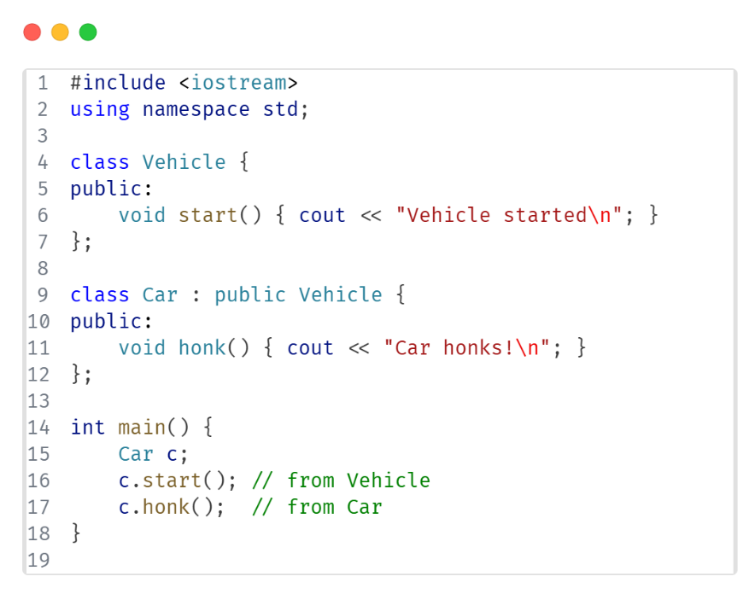
Definition: A mechanism by which a new class (derived) acquires properties and behaviors of an existing class (base).
Types:
- Single → One base, one derived.
- Multiple → Multiple bases, one derived.
- Multilevel → Derived class becomes base for another derived class.
- Hierarchical → One base class with multiple derived classes.
- Hybrid → Combination of types.
Advantages:
- Promotes code reusability.
- Supports extensibility.

2.4 Polymorphism
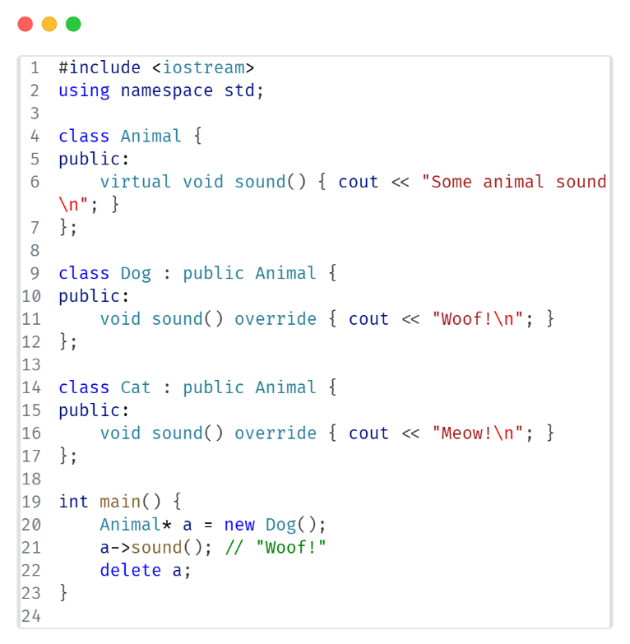
Definition: Ability of the same interface to represent different underlying forms (data types or behaviors).
Types in C++:
- Compile-time (Static) Polymorphism
  - Function overloading
  - Operator overloading
- Run-time (Dynamic) Polymorphism
  - Virtual functions
  - Function overriding

3. Other Important OOP Concepts in C++
3.1 Class vs Object
- Class: Blueprint/template for creating objects.
- Object: Instance of a class.

3.2 Constructor & Destructor
- Constructor: Special method called automatically when an object is created.
- Destructor: Special method called automatically when an object is destroyed.

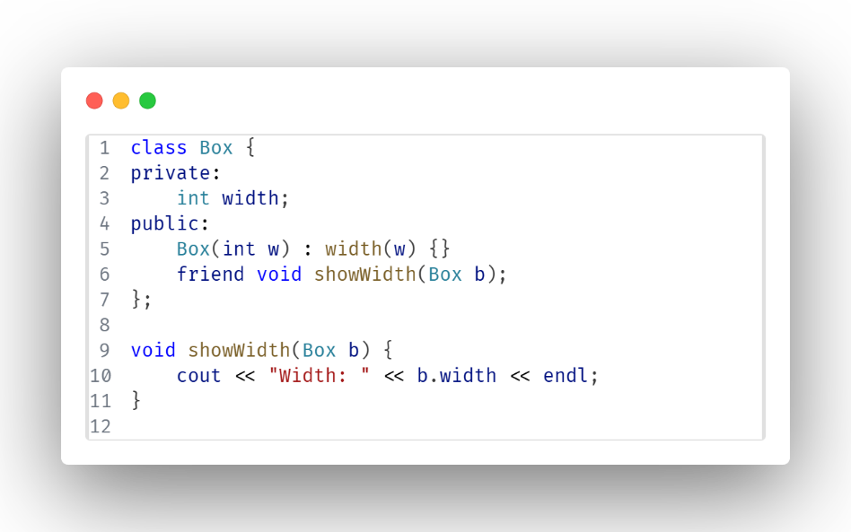
3.3 Friend Function
- Allows an external function to access private/protected members of a class.

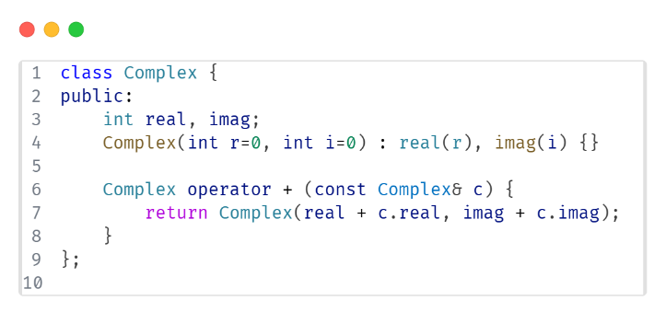
3.4 Operator Overloading
- Redefines how operators work for user-defined types.

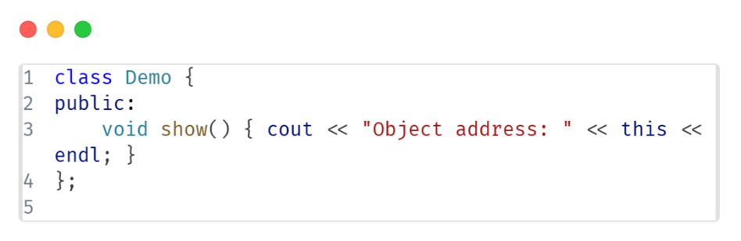
3.5 this Pointer
- Refers to the calling object’s address.

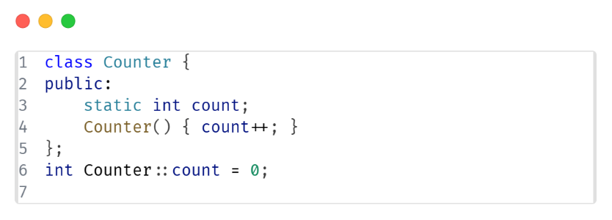
3.6 Static Members
- Belong to the class, not individual objects.

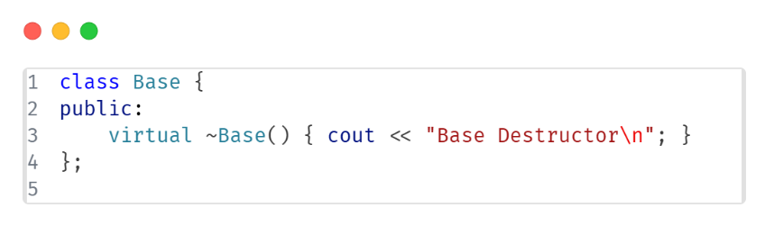
3.7 Virtual Destructor
- Ensures derived class destructors are called when deleting via a base pointer.

4. Advantages of OOP
- Modularity
- Reusability
- Scalability
- Maintainability
- Security through encapsulation

5. Disadvantages of OOP
- Slightly higher memory usage.
- Requires more upfront design effort.
- Can be complex for small programs.

6. Recap Table
Concept | Purpose | C++ Feature Used
Encapsulation | Data protection | Access specifiers
Abstraction | Hide complexity | Pure virtual functions
Inheritance | Code reusability | Base & derived classes
Polymorphism | Flexible behavior | Virtual functions, overloading

